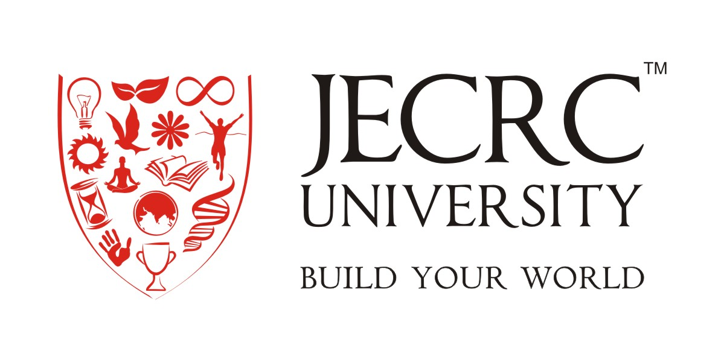

Faculty of Design
Syllabus and Course Structure

B.Sc. (GRAPHIC DESIGN)
(2018-2021)

Academic Program

Introduction
Graphic Design is the creative planning and execution of visual communication. One learns to create a combination of shapes and forms, words and images, in order to reproduce them in some flat medium (two dimensional - paper, cardboard, cloth, plastic, video, computer, or projection screen, on poster, billboard, or other signage) or in a three-dimensional form (fabricated or manufactured) in order to convey information to a targeted audience. All graphic design has a purpose or function. Usually its purpose is commercial to explain aesthetically something -- to express, inform, and influence the thoughts and actions of its audience.
This subject introduces the student to art intended to communicate information and advertising. The focus is on studying and using layout and design concepts used in the Graphic Design field. The students will employ both analog media (drawing with pencil and paper, etc.) and digital media -- using up-to-date computer tools (graphics hardware and software - for drawing, painting, layout, typography, scanning, and photography).
Advertising Design, Graphic Design, and illustration all disciplines that focus on effective and arresting visual communication. Advertising majors delve deeply into all aspects of the advertising process, from research/strategy, creative brief development, and campaign development to teamwork and presentation. Graphic design majors are challenged to research, develop, and refine projects that combine meaning with image-making and typographic form. Illustrators develop a strong personal style in their images and use their image-making skills to support the communication needs of a variety of clients in multiple contexts.
Mission Statement
The mission of the Faculty of Design is to build a successful career of its students. The school provides a prolific and dynamic program designed to meet individual needs of students with diverse aspirations, learning capacities, scope regimes, artistic sensibilities and innovations.
Program Mission Statement (GRAPHIC DESIGN)
The Program aims to encourage, foster and expose the students to a more diverse art and design practice through new research and developments within academic and professional parameters. From multidisciplinary approaches to self-directed studies, students initiate and integrate assimilated knowledge from a diverse range of subjects to arrive at innovative and challenging solutions to previously explored and unexplored notions including new technologies and techniques. Students are introduced to different ways of approaching, perceiving and appreciating advertising through studio and theory components within the course structure. Workshops, Seminars and Field visits help students to source trends and modern contexts through a critical eye. Fundamental knowledge of tools, materials and processes is complemented with development of ideas and concepts, leading to development of wearable and non-wearable portfolios, for the market.
Program Objectives:
An ability to apply profound understanding of Design and Advertising.
- An ability to design and Production.
- An ability to design a advertising Campaign.
- An ability to Idea to output.
- An ability to identify, Target audience and Market.
- An understanding of professional and ethical responsibility.
- An ability to communicate effectively.
- The broad education necessary to understand the impact of Design in global, economic, environmental, and societal context
- A recognition of the need for, and an ability to engage in life-long learning
- A knowledge of contemporary issues
- Students demonstrate how elements of time and place influence the visual characteristics, content, purpose and message of works of art.

Strategic Plan
The Faculty of Design at JECRC University is a platform for integrating contemporary design sensibilities with traditional aesthetic values. We provide a space for highly skilled crafts women/men, designers and new entrants who aspire to become professional advertising field and designers.

Program Objective’s Assessment
The following table illustrates how each of the above program objectives is measured and the actions taken as a result of these measurements.
The three tools for assessments of program objectives are:
1. Employer Survey
2. Alumni Survey
3. Graduating Students Survey
4. Existing student Survey
5. Parents Survey

Objectives | How Measured | When to be Measured | Improvement Identified | Improvement Made
1 | Graduating students survey | at conclusion of three year program | Better integration of skills required between different design areas | Development of projects and close monitoring of design objectives and outcomes
2 | Alumni survey graduating students survey | Within one year of graduation | Diversity of exposure to various art and design outcomes | Close supervision of research oriented projects and following of design events, fairs and competitions
3 | Employer survey | Within one year of graduation after completion of community projects | Further development of industry oriented assignments | More frequent interaction between academia and the industry through internships and visits
4 | Graduating students survey | Conclusion of four year program | Identification of community related projects | Introduction of community based design modules as part of coursework
5 | Alumni survey graduating students survey | Within one year of graduation | More emphasis on research and analytical skills | Emphasis on research skill development through theory courses
6. | Alumni survey graduating students survey | Conclusion of four year program | Development of communication and presentation skills | Regular critiques and presentations to peers and professionals
7 | Alumni survey employer survey | Within one year of graduation | Need for market surveys and comparative ad campaigns | Inclusion of target audiences, costing and marketing mix ad campaign

Course Outcomes are:
1. Problem Solving: Solve communication problems and carry projects from creation through to the production process; including the skills of problem identification, research and information gathering, analysis, generation of alternative solutions, prototyping, user testing, integration of feedback and the evaluation of outcomes.
2. Communication. Describe and respond to the audiences and contexts, which communication solutions must address, including recognition of the physical, cognitive, cultural, and social human factors that shape design decisions.
3. Demonstration. Create and develop visual concepts in response to communication problems, including an understanding of the principles of visual organization, information hierarchy, symbolic representation, typography, aesthetics, and the construction of original meaningful forms.
4. Technique. Understand tools and technology, including their roles in the creation, reproduction, and distribution of visual messages. Relevant tools and technologies include drawing, offset printing, photography, and time-based and interactive media.
5. Application. Be able both to determine the mode(s) of production required to achieve a specific product and to demonstrate level-appropriate mastery of skills, manual and/or digital, necessary to achieve those products. Apply the principles of color, composition, hierarchy, typography as they relate in the various media—digital, print, motion, 3-D, etc.—that exist in design.
6. Aesthetic Fluency. Recognize and apply aesthetic principles of design history, theory, and criticism from a variety of perspectives, including those of art history, linguistics, communication and information theory, technology, and the social and cultural use of design objects.
7. Professionalism. Understand the basic business practices and trade ethics related to graphic arts, including the ability to organize design projects and to work productively in client-designer and team relationships in the implementation and evaluation of projects.
8. Portfolio. Organize and present a portfolio of work that gives evidence of the skills, knowledge, and abilities to begin a graphic design career or transfer to a four-year college for additional study.

Program Specific Outcome:

PSO1: Demonstrate fluency in the visual vocabulary and technical skills relevant to Graphic Design:
  - Demonstrate excellence in typographic practice using text typography, display typography, and grid systems across analog and digital media.
  - Display image-making expertise and the development of visual narratives using photography, illustration, and type-as-image across analog and digital media.
  - Convey Ideas, clearly and confidently, in their work, their speech and their writing.
  - Apply the rigor of research and conceptualization to their work via prototypes and presentations.
PSO2: Imagine and articulate research, conceptualization and varied solutions to any problem:
  - Evaluate and synthesize different points of view and determine appropriate solutions to serve specific outcomes.
  - Apply critical thinking and flexibility to formulate appropriate, practical, and actionable responses to any question.
  - Think broadly, be receptive to provocative ideas, and be prepared to generate novel and unexpected outcomes
  - Articulate the diverse ethical components associated with any cultural production.
  - Integrate life-long learning practices to constantly evolve career-relevant skills.
  - Recognize, be curious and tolerant of cultural and social diversity regarding both client and audience.
PSO3: Leverage research, innovative processing and context to generate effective ideas:
  - Constantly and prominently consider the cultural, social and economical environment in which their ideas, products, and strategies will live.
  - Learn through our multicultural learning environment to become “visual translators”.
  - Move confidently and creatively between inquiry, theory, and practice.
  - Embrace the creative process as dynamic progression of research, speculation and experimentation, prototyping and refinement.
  - Demonstrate knowledge of historical, current, and innovative events and ideas, and interpret those viewpoints through the framework of communication design.
  - Assess the impact their actions have on other individuals, communities and the sustainability of our environment.

Title of Degree Program
B.Sc. in Graphic Design
Definition of credit hour:
One credit hour is 1 hour of theory lecture and one credit hour is 2 hours of practical work.
Degree plan
Following is the list of courses from
B.Sc. in Graphic Design

B.Sc. Graphic Design Semester I
Sr. No. | Course Code | Course Title | L | T | P | Contact Hrs. | Credits | Type
1 | BMC128B | Business Communication & Personality Development | 3 | - | - | 3 | 3
2 | BMC051B | Environmental Science | 4 | - | - | 4 | 4
3 | BGD101B | Design Foundation | - | - | 12 | 12 | 6
4 | BGD102B | Basic Art And Design | - | - | 3 | 3 | 3
5 | BGD103B | Calligraphy & Typography (Type Design & Application) |  | 0 | 6 | 6 | 3
6 | BGD104B | Fundamentals of Computer | 3 | - | - | 3 | 3
 |  | Total | 10 | 0 | 21 | 31 | 22

B.Sc. Graphic Design Semester II
Sr. No. | Course Code | Course Title | L | T | P | Contact Hrs. | Credits | TYPE
1 | BGD201B | Advertising Art & Ideas | 6 | 0 | - | 6 | 6
2 | BGD202B | Basic Photography | 0 | 0 | 4 | 4 | 2
3 | BGD203B | Computer Graphic-I | - | 0 | 12 | 12 | 6
4 | BGD204B | Illustration and Rendering I | - | 0 | 4 | 4 | 2
5 | BGD205B | Graphic Design -I | - | 0 | 6 | 6 | 3
 |  | Total | 6 | 0 | 26 | 32 | 18

B.Sc. Graphic Design Semester III
Sr. No. | Course Code | Course Title | L | T | P | Contact Hrs. | Credits | Type
1 | BGD301B | History of design | 4 | 0 | - | 4 | 4
2 | BGD302B | Contextual Photography | - | 0 | 4 | 4 | 2
3 | BGD303B | Graphic Design- II |  | 0 | 6 | 6 | 3
4 | BGD304B | Computer Graphic- II | - | 0 | 12 | 12 | 6
5 | BGD305B | Illustration and Rendering -II | - | 0 | 6 | 6 | 3
 |  | Total | 4 | 0 | 28 | 32 | 18

B.Sc. Graphic Design Semester IV
Sr. No. | Course Code | Course Title | L | T | P | Contact Hrs. | Credits | TYPE
1 | BGD401B | Branding & Corporate Identity | 6 | 0 | - | 6 | 6
2 | BGD402B | Printing and Production Methods | 6 | 0 | - | 6 | 6
3 | BGD403B | Computer Graphic-III | - | 0 | 6 | 6 | 3
4 | BGD404B | Professional Photography | - | 0 | 4 | 4 | 2
5 | BGD405B | Story Board Making / Short Film Making | - | 0 | 4 | 4 | 2
6 | BGD406B | Design Project- I- Corporate Identity | - | 0 | 6 | 6 | 3
 |  | Total | 12 | 0 | 20 | 32 | 22

B.Sc. Graphic Design Semester V
Sr. No. | Course Code | Course Title | L | T | P | Contact Hrs. | Credits | Type
1 | BGD501B | Entrepreneurship | 3 | 0 | - | 3 | 3
2 | BGD502B | Communication theory and media studies | 6 | 0 | - | 6 | 6
3 | BGD503B | Research Project | - | 0 | 4 | 4 | 2
4 | BGD504B | Computer Graphic- IV | - | 0 | 6 | 6 | 3
5 | BGD505B | Communication Campaign |  | 0 | 12 | 12 | 6
 |  | Total | 9 | 0 | 22 | 31 | 20

B.Sc. Graphic Design Semester VI
S. No. | Code | Subject | L | T | P | Contact Hrs. | Credits | Type
- 1 | BGD601B | Internship | 0 | 0 | 0 | - | 18
 | BGD602B | Portfolio Development | 0 | 0 | 0 | - | 6
 |  | Total |  |  |  | - | 24
Semester Wise Credit Distribution
1st | 2nd | 3rd | 4th | 5th | 6th | Total | Minimum credit Required
25 | 23 | 19 | 25 | 23 | 18 | 133 | 133

B.Sc. Graphic Design Program Educational Objective (PEO’s):
A graduate of the Graphic Design Program should:

PEO- I
Creating Art: Students know and apply the arts, disciplines, techniques and processes to communicate in original or interpretive work.
PEO- II
Art in Context: Students demonstrate how elements of time and place influence the visual characteristics, content, purpose and message of works of art.
PEO- III
Art as Inquiry: Students demonstrate how the arts reveal universal concepts and themes. Students reflect upon and assess the characteristics and merits of their work and the work of others.

